**SQL LAB ASSIGNMENT**

NAME: AGILAMBAL S

REG NO : 731621121003

DEPARTMENT:BME

**1.Create the following tables**

**Table-1**

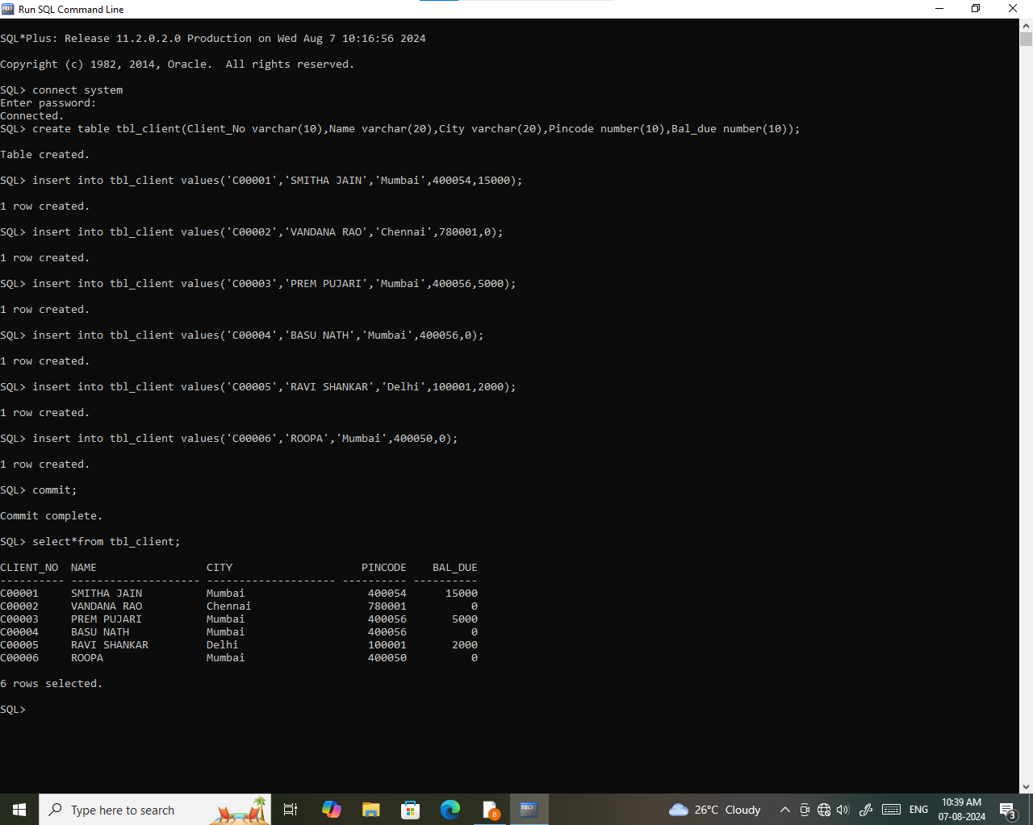

**Table-2**

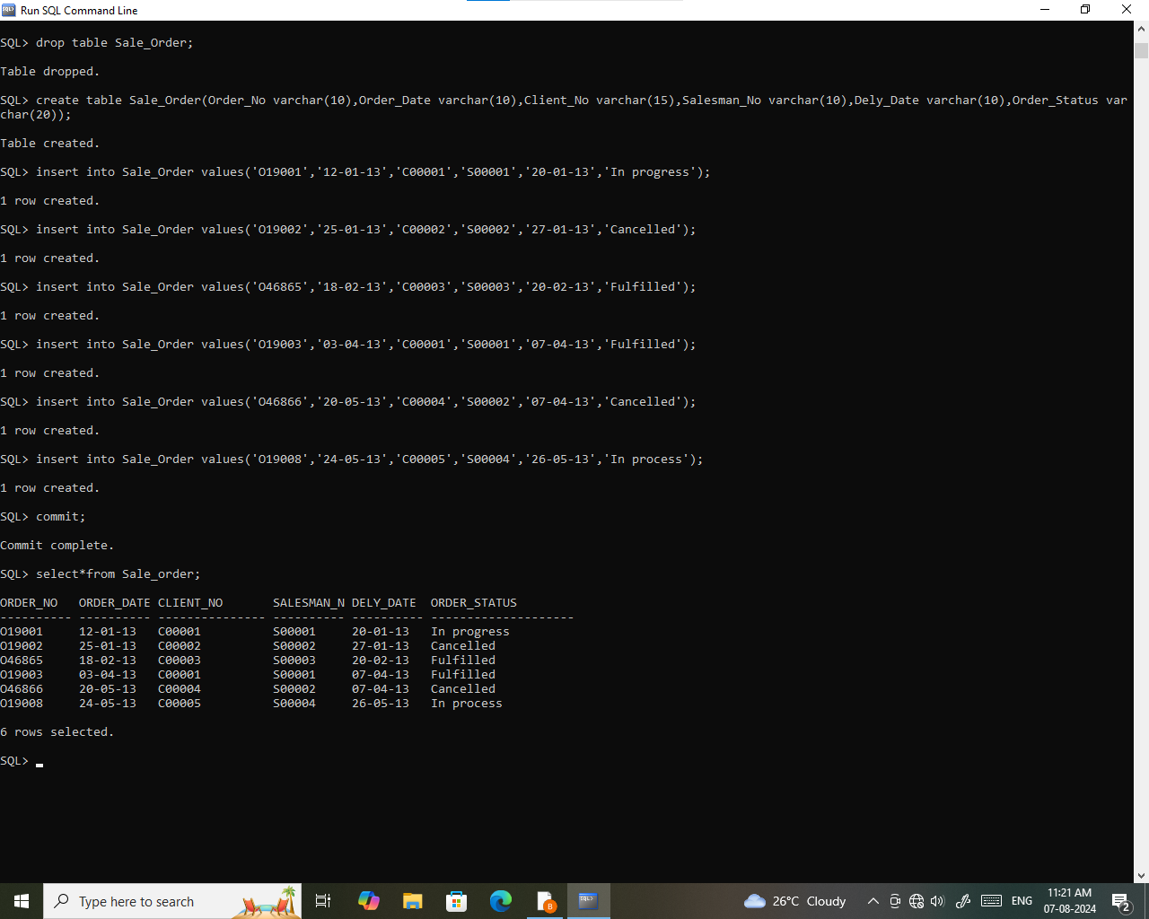

**2.Write SQL commands for the following:**

1.List all details from the client master table for clients whose Bal_due = 0.

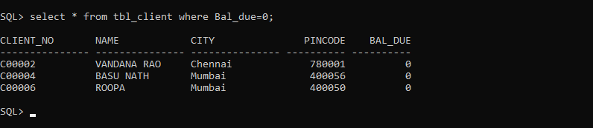

2. Update table client_master, Change city of Client_no C00004 to Jaipur.

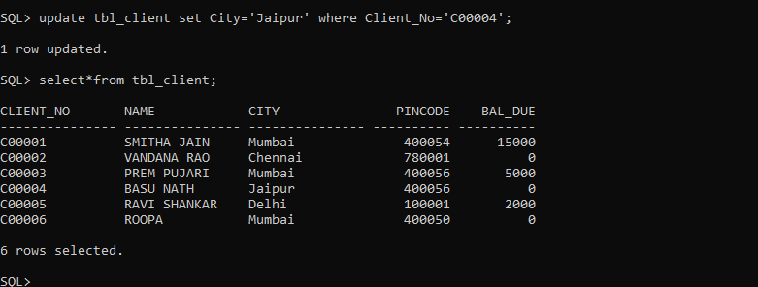

3. Retrieve records of clients residing in Mumbai.

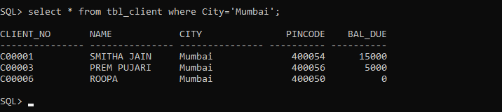

4. Find the name and address of customer who has placed Order_no 'O19003' and 'O19002' respectively.

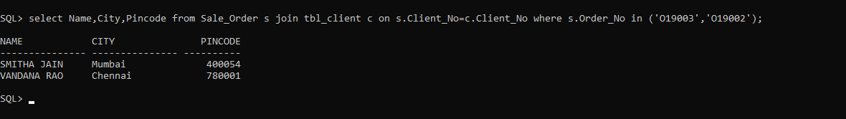

5. Construct English like sentence from the table client_master ({Customer name} live in the city of {city}).

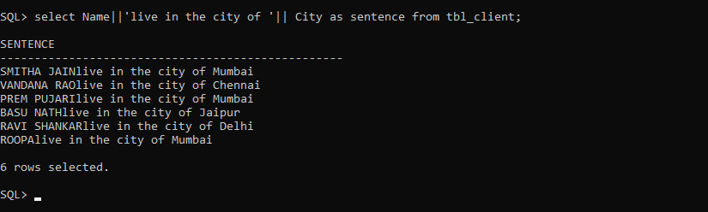

6. List the client_no, name, city and pincode of clients whose Order_status is "In process".

